Tencent Cloud Adoption Solution

Contents _
1 Professional Service Team 2
2 Migration progress 4
2.1 Prepare 5
2.1.1 Information Collection 5
2.1.2 Business Sorting 5
2.2 Plan formulation 6
2.2.1 Design _ 6
2.2.2 Solution verification 21
2.2.3 Program review 22
2.3 Program implementation 22
2.3.1 Environmental preparation 22
2.3.2 Cloud migration drill 22
2.3.3 Cloud implementation 23
2.3.4 Business cutover 23
2.4 Acceptance summary 23
2.4.1 Cloud acceptance 23
2.4.2 Summary of cloud migration 24
2.4.3 Cloud optimization 24

- Professional Service Team
The entire process of moving to cloud, from strategic analysis to scenario analysis, and then to cloud deployment strategy, is a complex and highly dependent project on professionalism. Based on rich practical experience, Tencent's cloud service team provides professional cloud consulting and cloud implementation services.
Cloud consulting service mainly helps enterprises to find answers of strategic questions such as why to go to the cloud and project planning, while cloud implementation service mainly solves tactical issues such as how to better migrate applications to the cloud. The two can be combined with each other or executed independently.
- Migration Consulting Service
Tencent Cloud Consulting Services is a planning and consulting service provided to enterprises for cloud related applications, addressing the challenges and problems faced by enterprises in executing cloud strategies and moving towards Tencent Cloud. The main service content includes cloud planning and application cloud solution design, helping customers customize and plan their technology architectures and typical application cloud solutions on Tencent Cloud, fully leveraging the advantages of Tencent Cloud services, quickly, securely, and reliably migrating applications to stable cloud environments, achieving value growth and operational optimization of cloud investments.
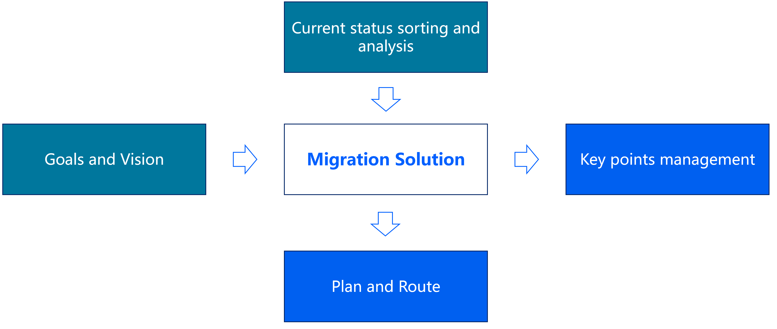
- Migration implementation services
Tencent Cloud Implementation Service is a cloud implementation service based on Tencent Cloud product system in both private and public cloud scenarios. This service provides customers with secure, stable, and reliable cloud implementation solutions, helping to solve various problems encountered by customers during the cloud deployment process, guiding them to use Tencent Cloud products and technologies more reasonably and efficiently, and thus maximizing the advantages of cloud computing.

The main service content includes cloud demand research and feasibility assessment, migration technology solution design, migration drills, migration implementation, migration cutover, etc. Support scenarios include cloud migration, PaaS service adaptation, cloud native transformation, etc.
The following text will introduce the process of application migration to the cloud and key issues in practice from two different cloud migration routes: public cloud and private cloud.

- Migration progress
There are differences and uncertainties in the business environment for enterprises to go to the cloud, and technical personnel need scientific methods to standardize and ensure the smooth deployment of business to the cloud. The typical public cloud deployment process is divided into four stages, namely: research and evaluation, plan formulation, plan implementation, and acceptance summary. The overall cloud process diagram is as follows:
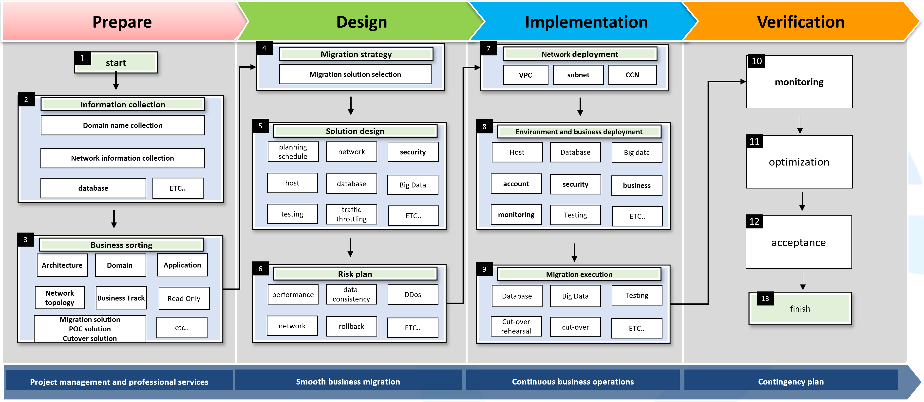

The key nodes of the cloud process on the public cloud are explained as follows:
- Prepare: Research and evaluation, conduct systematic research on the current business situation, including aspects such as business, systems, technology, and resources; Assess the difficulty of cloud deployment in business, the adaptability of the platform, and analyze the overall feasibility of cloud deployment in business.
- Design: Plan formulation. Based on the results of preliminary research and evaluation, combined with the capabilities of the cloud platform, Tencent's cloud service team collaborates with the enterprise to jointly develop an overall plan for cloud deployment.
- Implementation: Under the guidance of the cloud based plan, the business is implemented and landed in the cloud, mainly including business deployment testing, business transformation, data migration, and business cutover.
- Verification: Acceptance summary, After the traffic is switched to the cloud platform, the system officially enters the operation and maintenance phase, and is handed over to the relevant team for operation.
  - Prepare
    - Information Collection
Collect information to get a overall requirement research. In this phase, mainly uses methods such as survey forms, customer interviews, and business observations to understand the current situation of the enterprise, so that Tencent's cloud service team can fully understand the current business architecture and enterprise cloud requirements, and provide data support for subsequent cloud feasibility assessment, cloud deployment plan formulation, and plan implementation.
Information collected includes 3 parts: business research, system research, and resource research.
- Business research: including business types, business characteristics, business operations, and business indicators.
- System research: including overall system deployment architecture, business data flow, high business availability, system coupling, scalability, and security.
- Resource research: including system resource types and quantities, software and hardware versions and advanced features, capacity, performance, and other aspects.
    - Business Sorting
Based on the information collected, Tencent Cloud's cloud service team conducts a feasibility assessment on migrating enterprise business to the cloud, and comprehensively evaluates the cloud migration cycle, labor costs, and technical difficulties for businesses suitable for migrating to the cloud. The cloud migration evaluation mainly considers the following aspects:
- Platform adaptation assessment: Evaluate the adaptability of the cloud platform based on the application system 's dependence on software and hardware. For example, some financial systems rely heavily on Udun or customized hardware. Evaluate whether the cloud platform is compatible or solve it with customized solutions .
- Business transformation assessment: Based on the business status and technical characteristics, combined with the capabilities of the cloud platform, comprehensively assess the risks of system transformation ; especially cloud PaaS and SaaS have rich product functions and may require business heterogeneity to maximize business cloud benefits. .
- Performance risk assessment: Conduct a comprehensive assessment based on system performance requirements and existing performance bottlenecks , combined with cloud platform product capabilities. For example, migrating a locally built database to a cloud database product may require POC tuning and testing.
- Security risk assessment: The existing security system requires adaptation to the capabilities of the cloud platform, including application security , operation and maintenance security , network security , data auditing , encryption, etc. For example, some industries have customized encryption devices for data security, or bastion machines have special usage scenarios that need to be evaluated.
- Resource risk assessment: Overall cloud migration planning requires an assessment of cloud platform resources and cloud human resources . The cloud platform's resource scanning tool automatically scans and outputs resource statistics reports for the migrated business environment, improving the efficiency of cloud preparations .
Theoretically, most business systems can be migrated to the cloud . Based on the experience of previous cloud customers , businesses that meet the following three characteristics are more suitable for cloud migration :
- The application system has no special dependencies on hardware.
- Application systems can improve performance by adding nodes.
- The application system and data storage are effectively separated, and the real-time communication between modules is not very sensitive.
  - Design
After the preliminary research and evaluation , enterprises need to design an overall cloud plan that are suitable for cloud migration . The plan aims at migrating business to the cloud and builds a new system architecture on the cloud to ensure that business can be smoothly migrated to the cloud . The following four dimensions are mainly considered in the plan formulation stage :
- Clear cloud migration goals and routes.
- Project management and quality control during the cloud migration process .
- , verification and review of business technology architecture on the cloud .
- Overall migration plan design , verification and review .
    - Solution Design
      - Migration Strategy
Migration is an enterprise strategic project, requiring heavy personnel investment and a long project cycle . To this end, the entire cloud migration goal needs to be split into multiple subtasks to ensure that the overall migration is completed as planned , including:
- Determine the cloud migration business and overall time plan : Through preliminary research and evaluation, take stock of the difficulty of migrating the business to the cloud , and determine the cloud migration strategy . For example: Which businesses are suitable for migrating to the cloud , suitable for refactoring to the cloud, or not suitable for migrating to the cloud.
- Determine business migration rules: The mainstream cloud migration methods include full migration and smooth migration. Develop overall business cloud migration rules and standards to standardize the migration methods of each business.
- Cloud business priority : business logic should be simple before complex, and business types should be ordinary before core.
For businesses suitable for cloud migration, the entire cloud migration project needs to be planned and managed. The goal of migrating to the cloud will be split into multiple subtasks. Each subtask has a clear person in charge and an expected completion time to ensure that the cloud migrating project is completed as planned.
The entire cloud project management mainly includes the following aspects:
- Early preparation: including account application, domain name registration, migration plan communication, resource planning, network planning, model testing and migration testing, etc.
- Network construction: including dedicated line construction. If you synchronize data through VPN or public network, you can ignore this item.
- Operation and maintenance management: Operation and maintenance management of cloud resources, including monitoring and alarming, CMDB management, CI/CD management, and operation of public components on the cloud.
- Business deployment: Applications are deployed and tested.
- Data migration: database and object storage are migrated to the cloud.
- Delivery and cutover: Ensure smooth business cutover and smooth business operation on the cloud through business cutover drills and cutover rollback plans.
Migrating enterprise business to the cloud is a large and complex project that requires the coordination and cooperation of multiple parties. Therefore, each stage requires a person in charge to coordinate the overall management and coordination of the resources of all parties. The following table introduces the division of responsibilities between the enterprise and Tencent Cloud in the process of migrating business to the cloud :
migration stage | Details | client | Tencent Cloud
Research and evaluation | Systematic research | S | R
Research and evaluation | Migration strategy | R | R
Research and evaluation | Migration risk assessment | S | R
Plan formulation | Cloud technology architecture solution | S | R
Plan formulation | Cloud process planning and management | S | R
Plan formulation | Solution verification | S | R
Plan formulation | Program review | S | R
Program implementation | Environmental preparation | R | S
Program implementation | Cloud migration drill | R | S
Program implementation | Cloud implementation | R | S
Program implementation | Business cutover | R | S
Acceptance summary | Cloud acceptance | R | S
Acceptance summary | Summary of cloud migration | R | R
Acceptance summary | Cloud optimization | R | S
R-Responsible executor S-Support is responsible for cooperation

Cloud migration acceptance will involve cloud- side commercial billing, and both parties need to negotiate acceptance standards in advance to avoid target deviations between the two parties after cloud migration, which will affect the delivery results of the cloud migration project . Usually, cloud migration acceptance can be completed only if the cloud business can run smoothly within one cycle . For details, please refer to:
- customer internal rating failures due to cloud side issues for 15 consecutive calendar days .
- be performed by the customer's business side .
- If a failure occurs due to cloud side reasons , the cloud side will take the lead. After the client side cooperates to completely fix the problem, the business will continue to be observed for a cycle.
      - Resource Management Design
As public cloud products become more and more abundant and can meet more and more business scenarios, customers will rely more on the capabilities of the cloud platform and have more requirements for capacity , cost and stability . Resource management planning mainly considers the following dimensions:
- Business capacity planning : The massive resources of the public cloud can meet the needs of enterprises to purchase on-demand , helping enterprises to plan cloud resources more accurately ; if there is an explosive increase in business , such as " Double Eleven " and " New Year's Eve Party " ” and other major events require enterprises to evaluate and prepare resources in advance and make comprehensive assessments on the cloud side. Objectively speaking, the construction scale of a single data center is limited. Priority is given to the main cloud campus with rich resources to reduce the potential risk of insufficient resources in a single data center , resulting in cross- availability zone business access and increased access delays .
- Reasonable business costs : The goal of enterprise digital transformation is to reduce costs and increase efficiency. As an industrial Internet assistant, Tencent Cloud uses the capabilities of the cloud platform to more flexibly and effectively reduce costs for enterprises during the cloud migration process . The main aspects are as follows:
- Flexible purchasing: Use reasonable payment methods and purchase resources on demand to avoid idle resources, and enterprises can flexibly control costs.
- Improve resource utilization : Use cloud EKS and elastic scaling capabilities to dynamically adjust resources based on actual business conditions to improve resource utilization .
- System resource cost : There are a variety of computing resource types and storage resources on the cloud for businesses to choose from. It is recommended to give priority to the more cost-effective SA series servers . Regarding object storage , it is recommended to use the COS intelligent tiering function to automatically separate hot and cold data to reduce costs.
- Operation and maintenance costs : Each product of the cloud platform has supporting services, such as monitoring alarms , automatic inspections , data upgrades , logging and other services, to reduce daily operation and maintenance system maintenance.
- Business disaster recovery construction : As enterprises have higher and higher requirements for business continuity, enterprises have strong demands for disaster recovery construction across availability zones or multiple regions . Mainstream cloud products already have multi- availability zones and off-site disaster recovery capabilities, helping enterprises improve the efficiency of business disaster recovery capabilities , mainly in the following aspects :
  - Lowering the technical threshold for disaster recovery construction : Mainstream cloud products have cross-region or cross-availability zone disaster recovery capabilities, reducing enterprises' reliance on and research on many open source solutions. At the same time, stability is guaranteed by the SLA of cloud products .
  - Component HA switching capability construction : If the cloud computer room fails across availability zones , instances with cross- availability zone capabilities support automatic switching; there is no need for enterprises to build automatic component HA detection and switching capabilities , and subsequent maintenance costs.
  - Data synchronization stability guarantee : Data synchronization stability is self-evident for disaster recovery construction . Instances with cross- availability zone capabilities naturally guarantee data synchronization stability, and enterprises do not need to maintain open source community synchronization tools.
  - Monitoring and alarm capability building : Cloud instances across availability zones or regions have supporting monitoring and alarm capabilities to sense business health in a timely manner .
  - Reduce enterprise labor costs : Convenient operations on the cloud provide one-stop disaster recovery construction; at the same time, the labor costs of maintenance and secondary development of community open source software are reduced.
      - Account System Design
Account system design refers to the enterprise formulating standards for the account system and setting reasonable permissions for accounts or account groups to ensure that the enterprise can manage resources safely and effectively. The account system is based on the classification of accounts , resources and permissions. The three are effectively combined to authorize accounts with the smallest granularity according to resources and permissions. Account system design needs to consider the following dimensions:
- Account classification: Each sub-account is classified according to enterprise needs and granted corresponding permissions. For example, the financial administrator grants financial-related permissions, such as payment and invoicing; the database administrator grants read and write permissions to the cloud database.
- Resource classification: Resources are classified by tags. Multiple tags can be added to a resource to facilitate account management of resources more flexibly . For example, with multiple online application systems , each application uses different labels to distinguish resources , allowing for more secure and controllable resource management.
- Permission classification: Permission granularity is divided into service level, operation level and resource level. Different cloud products also have different support for permissions. For example, cloud servers are at the resource level and can accurately control permissions on a single server ; HTTPDNS is at the operation level and can control permissions for each operation of the service ; domain name user registration has service-level permissions and can only control permissions on the service. Similar to a service switch, the authorized account has all permissions for the service, otherwise it is denied use.
      - Network Design
The public cloud VPC private network provides enterprises with exclusive network space on the cloud, provides network services for cloud resources, and provides security policies and multiple interconnection methods to help enterprises deploy and plan cloud networks. Network solution design mainly includes regional availability zone planning, VPC and subnet planning, and hybrid cloud network architecture:
- Regional availability zone planning
Public cloud infrastructure spans the globe, operating multiple Availability Zones in multiple geographic regions around the world. Compared with traditional data center infrastructure, enterprises have more choices and can plan regions and availability zones based on business development.
Regional planning: On the one hand, it depends on business access delay. For example, business end users are mainly concentrated in Guangdong and Guangxi. It is recommended to choose the South China region for the cloud network; on the other hand, it depends on compliance requirements , mainly for overseas and financial businesses. If an enterprise's business is deployed in multiple regions, interconnection between different regions can be achieved through the cloud network.
Availability zone planning: There are multiple availability zones on the same regional cloud for enterprises to choose from. Usually, the delay between different availability zones in the same region will not exceed 3ms. If the business has disaster recovery requirements and the business is sensitive to network time consumption, it is recommended to select the two closest availability zones in the same region to plan the network; it is recommended that services with high frequency of mutual visits be deployed in the same availability zone to reduce cross- availability zone access delays. hour. If the mutual visit business grows rapidly, it is recommended to choose the main public cloud campus to meet the demand for future business resource growth.
- VPC&subnet planning
A VPC private network can only belong to one region. At the same time, a VPC can be divided into multiple subnets. The network interconnection between different V PCs is through cloud networking. Different subnets in the same V PC are interconnected by default. Network and subnet planning mainly considers the number of VPCs , the number of subnets, network segment planning, routing table design, etc.:
VPCs : If the enterprise's business scale is small and deployed in the same region, and the services do not need to be isolated by VPC , it is recommended to use a VPC network. Create different subnets in the same VPC network and finely control traffic through routing tables . If enterprise services need to be deployed in different regions, a VPC network needs to be created in each region , and communication between different VPCs must be implemented through cloud networking; if enterprise services in the same region need to be isolated through VPC networks, each business Create a VPC network. Currently, a single account can create up to 20 VPC networks in the same region .
Number of subnets: A VPC network can create multiple subnets at the same time (default is up to 100 subnets ). The default subnets in the same VPC network are interconnected, and the traffic can be finely controlled through ACL . It is also recommended to implement cross-availability zone disaster recovery. That is, create at least two subnets in different availability zones in a private network .
VPC network segment planning: Once the network segment mask of the VPC network and subnet is set, it cannot be modified. Therefore, rational planning of private networks and subnet segments based on business scale and communication scenarios will be beneficial to the smooth expansion and operation and maintenance of later services. Currently, enterprises can use any of the following network segments as VPC network segments:
10.0.0.0 - 10.255.255.255 (the mask range needs to be between 16 - 28)
172.16.0.0 - 172.31.255.255 (the mask range needs to be between 16 - 28)
192.168.0.0 - 192.168.255.255 (the mask range needs to be between 16 - 28)

Subnet segment planning: For subnet segment planning , select a network segment within the VPC network segment range or the same as the VPC network segment as the subnet segment ; the subnet cannot be modified after it is created. When creating a subnet, the subnet should be The IP capacity can meet current business needs, and the subnet should not be too large to prevent subsequent business expansion from being able to create subnets; in addition, the combination is based on business needs, industry mainstream business dimensions , project dimensions , and R&D/test/production environments. divide .
Routing table design: Routing tables mainly control the direction of traffic within a subnet, and each subnet can only be bound to one routing table. If the intranet traffic directions between different subnets of the enterprise are the same or similar, it is recommended to use a routing table and control the traffic through ACLs and security groups; if the intranet traffic directions between different subnets are greatly different, it is recommended to create multiple routing tables. Each subnet is bound to a different routing table, and the flow direction is controlled through routing policies.
- Hybrid cloud network high availability architecture
Enterprise services are deployed in both the off-cloud data center and the on-cloud VPC network, the on-cloud and off-cloud business interoperability can be achieved through dedicated lines or VPN connections. To improve network high availability, you can create dedicated line channels and VPN connection services at the same time, and configure the two links as primary and backup links. Among them, the dedicated line channel is the main line and the VPN channel is the backup line to achieve redundant communication.
Dedicated line channel (main line): The local IDC connects to different POP points in the cloud through multiple physical dedicated lines , and connects the dedicated line channel to the cloud network dedicated line gateway. Connect the cloud network gateway and VPC to the cloud network to realize business interoperability between IDC and cloud VPC. Normally, all communication traffic between the local IDC and VPC is forwarded through the cloud network through physical dedicated lines . In fact, if one dedicated line is abnormal, the traffic can be automatically switched to other dedicated lines for carrying.
VPN tunnel (backup line ): The local IDC and the cloud VPC establish a VPN secure tunnel to realize business communication on and off the cloud. When all dedicated line links are abnormal, traffic can be switched to this link to ensure business availability.
      - Application Architecture Design
More and more enterprises are deploying application systems on the cloud and using cloud platform products to build low-cost, elastic, highly available, and scalable IT business systems. However, migrating traditional applications to the cloud will face many challenges, which may involve business architecture transformation and even iterative upgrades of existing technology frameworks . Because the application system architecture design will be focused on in subsequent chapters.
      - Middleware Solution Design
As cloud products become more and more abundant, more and more businesses fully embrace cloud native, and middleware services gradually evolve from independent enterprise deployment to cloud PaaS .
the PaaS middleware on the cloud will be compatible with the industry's mainstream middleware and versions, and the business can be smoothly migrated to the cloud without any modification . The current P aa S middleware on the cloud includes CK afka and TDMQ . Among them, TDMQ on the cloud is based on the Pulsar self- developed platform and is compatible with open source middleware CMQ , RabbitMQ and RocketMQ . The PaaS middleware on the cloud has cross - availability zone or cross-regional disaster recovery capabilities and has natural high availability capabilities. If your cloud business is not highly sensitive to latency, it is recommended to give priority to cross- availability zone instances. While the cloud platform PaaS middleware is compatible with open source components, the solution design still needs to pay attention to the PaaS middleware platform restriction strategy. The relevant restriction strategies are explained on the Tencent Cloud official website . For example, if a CKafka message exceeds 12MB, it will cause abnormal sending and requires business transformation .
The industry's middleware cloud solutions mainly include single-write and dual-consumption, single-write and single-consumption , and MirrorMaker migration. Enterprises choose reasonable solutions based on business scenarios. Taking CKafka as an example, common cloud migration solutions are as follows:
- Single write, dual consumption: The overall migration process is simple, clear and easy to operate, with no data backlog and smooth transition. An additional set of consumers is required.
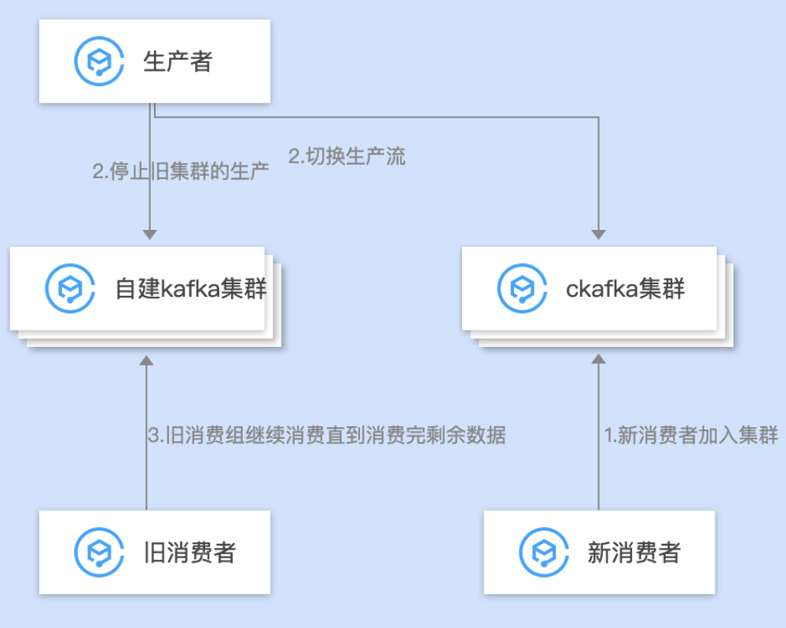
- Single write and single consumption : The overall migration process is simple, clear, easy to operate and smooth migration; however, after production is switched to the CKafka cluster and before old consumption is switched to the CKafka cluster, there will be a certain amount of accumulation in the CKafka cluster .
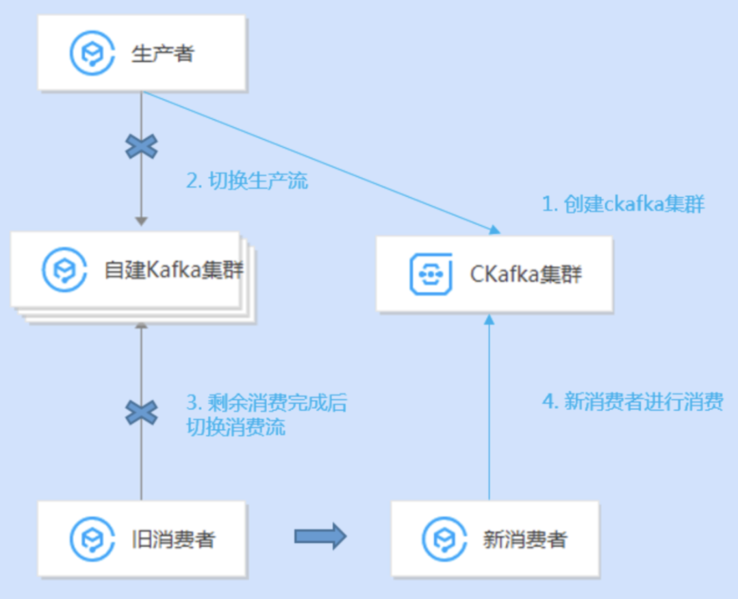
- MirrorMaker migration : The overall migration process is simple, clear, easy to operate, and migrates smoothly. However, consumers need to start consumption from scratch when switching to the destination cluster, and consumption idempotence needs to be ensured .
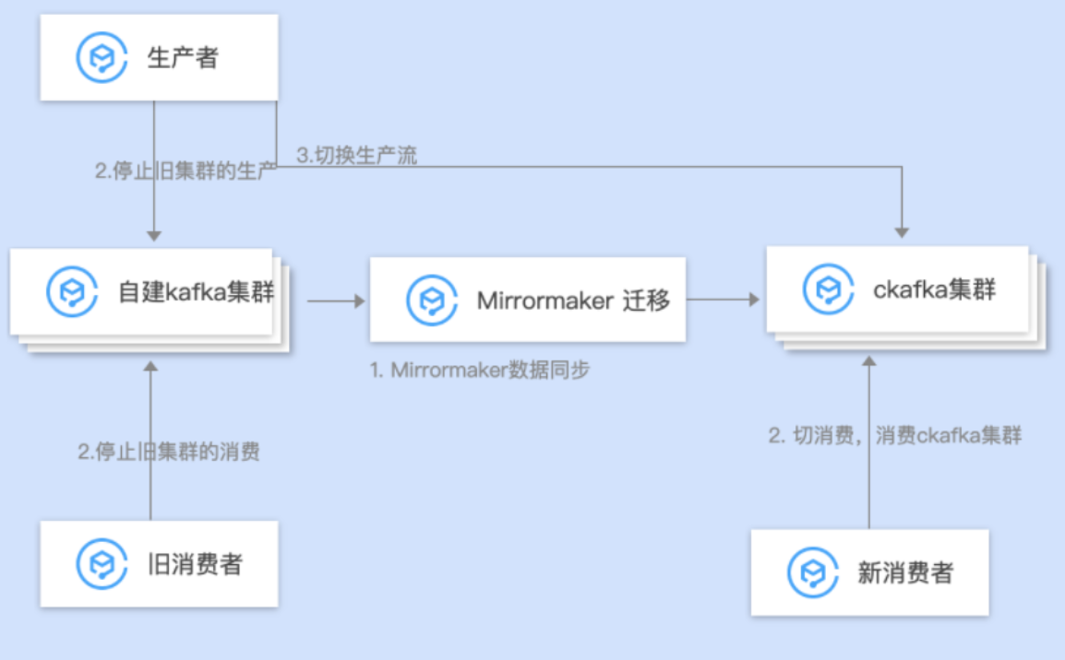
      - Database Scheme Design
The database is the backbone of the enterprise system, and its cloud solution is critical to the entire project. In addition to the active-standby and distributed cluster modes of cloud databases to ensure system stability, enterprises can also choose cross-regional or cross- availability zone database instances to enhance database stability. The cloud database supports businesses to purchase instances on demand, and supports one-click upgrade operations on the console page to complete database expansion very quickly. If the performance or capacity of the stand-alone version of the database reaches the upper limit , it can be smoothly migrated to the distributed database through the cloud, comprehensively solving the capacity problem of the enterprise's self-built database. Cloud database security is also reinforced in terms of account management, network isolation, data desensitization, data backup, and audit management.
As mentioned above, cloud databases can meet business requirements for availability, scalability, and security. However, the overall database solution also requires enterprises to consider comprehensively from the business level, which mainly includes the following aspects:
- Database table design specifications : The principle of database construction is that tables of the same type of business should be placed in one database. Tables of different businesses should try to avoid sharing the same database. Try to avoid performing cross-database association operations in the program . This operation will affect subsequent quick rollback. It will also have a certain impact. The database mainly stores data, and business logic is implemented through the application layer as much as possible, minimizing the use of advanced functions such as stored procedures, triggers, functions, events, and views. These functions have poor portability and scalability. The business has high read pressure and low consistency requirements. It is recommended to add read-only instances to separate read and write.
- It is recommended that the number of indexes on a single table should not exceed 5, and the number of fields in a single index should not exceed 5. Too many will not have a filtering effect. At the same time, because the index also takes up space, management also consumes resources. It is recommended to make reasonable use of covering indexes to reduce IO overhead and avoid redundant indexes.
- SQL writing specifications: It is recommended to avoid using large transactions as much as possible. It is recommended to split large transactions into small transactions to avoid master-slave delays ; search on demand , avoid full table scans , and avoid multi-layer subquery nested SQL statements, etc.
As businesses tend to be cloud-native, database usage is gradually transitioning from independent deployment to cloud databases. Database migration mainly relies on cloud DTS data migration capabilities to help enterprise databases migrate to the cloud. Enterprise database cloud solutions mainly focus on the following issues:
- Synchronization tool limitations: Currently, DTS migration only supports basic tables and views, but functions, triggers, and storage objects need to be added on the client side; related data objects need to be migrated at the same time, otherwise the migration will fail.
- Data synchronization: If you choose full data migration, writing new data to the source instance is prohibited during the data synchronization process, otherwise the source and target data will be inconsistent. For scenarios where data is written, in order to maintain data consistency in real time, it is recommended to choose full + incremental migration. DTS supports breakpoint resuming to avoid data resynchronization due to network interruptions and improve synchronization efficiency. Data synchronization speed depends on network bandwidth. If the amount of data is large and the cloud migration period is tight, it is recommended to expand the network bandwidth in advance.
- Parameter adaptation: After creating a new cloud database, key parameters need to be modified. For example, character set, case, transaction isolation level, etc.
      - Storage Solution Design
For enterprise business systems, structured data is usually stored in the database, and unstructured data is stored in the file system or NAS . On Tencent Cloud , unified storage solutions for unstructured data COS and CFS are provided .
Internet companies usually have very strong software development capabilities, and their business models are mostly write-once, read-multiple scenarios, which are very suitable for using object storage , so they mainly focus on object storage. However, as more traditional markets such as education, energy, government, and finance are reached, due to the particularity of business scenarios, a large number of users will choose file storage as the main storage method.
Data storage migration Migrate IDC or friend's storage to Tencent Cloud , mainly including the following two methods:
- Full migration: Migrate all the data from the source site at one time , and the business needs to be stopped . It is mainly suitable for business scenarios with large amounts of data. The cloud provides data migration tool Filetruck for file storage, COS Migration tool for object storage, and CDM for offline data migration. The full migration plan mainly considers the following aspects:
  - Time taken to migrate data : The amount of data migrated and network bandwidth determine the time taken to migrate data. If the migration cycle exceeds 10 days or the amount of data to be migrated exceeds 50TB, it is recommended to choose CDM offline migration. Otherwise, choose online tool migration, the time reference is as follows:
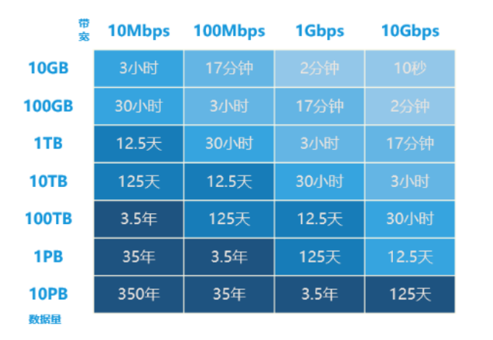
  - Data synchronization method : Usually the full + incremental method is used to synchronize data; full synchronization adopts offline or online migration depending on the data volume and migration cycle , while incremental synchronization is supported by online tools.
  - Data consistency verification : The cloud platform provides synchronization services . When the service is stopped, verification will be done by comparing the number and size of files in full or on a sample basis.
- Smooth migration: By using the stock + real-time incremental method for data migration, the business will not stop during the data migration. The smooth migration solution relies more on business transformation to complete . There are two main methods in the industry:
  - Real-time synchronization : The system can dynamically sense updated data files and synchronize them to the target storage in real-time.
  - Resource redirection : Resources access the target bucket first . If the target bucket does not have corresponding data , the data will be stored in the target bucket after being pulled from the source storage . Taking the COS synchronization solution as an example, data synchronization is achieved through the COS Migration tool, and a new COS back-to-source configuration is added . When the data is not synchronized, it is actively pulled from the source . The detailed process is as follows:
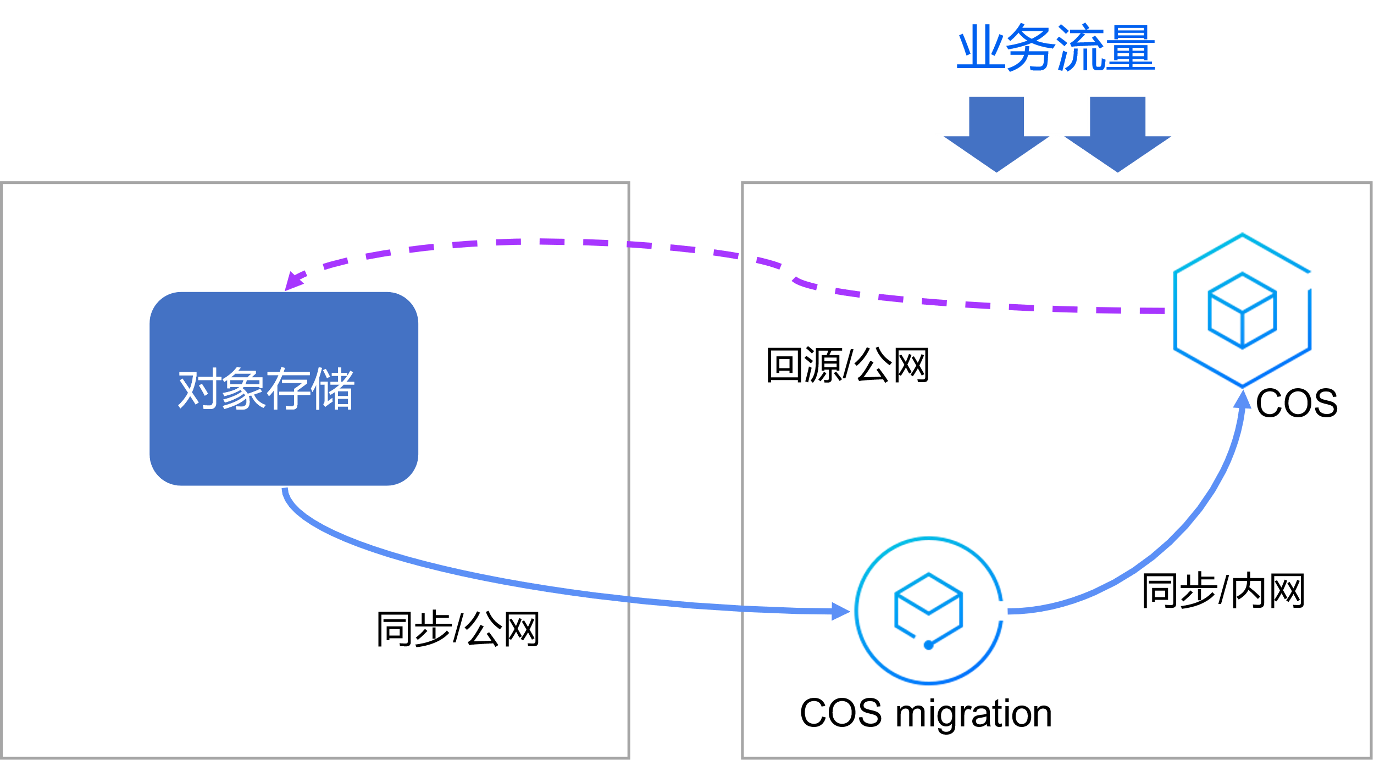
of the COS smooth migration plan is as follows :
Data synchronization : Use COS Migration for synchronization. During data migration, data inconsistencies may occur when modifying existing data storage. It is recommended to set periodic traversal mtime at the same time according to business sensitivity or execute the COS Migration task multiple times to minimize data inconsistencies caused by modifying existing data.
Business traffic : Switch the read and write requests of the business system to COS, open the back-to-origin setting function in the COS console, and the back-to-source address is the data source station. When COS does not have corresponding resources, it is retrieved from the source and stored in COS.
      - Cutover Plan Design
Business cutover refers to switching online traffic from the source system to the target system. For this purpose, a cutover plan that meets business requirements needs to be formulated to ensure that the business cutover meets business expectations. There are two main mainstream business cutover solutions:
Full business cutover refers to the new system completely replacing the original system, and a one-time cutover of the system that needs to be migrated. After the business cutover is completed, the application system traffic is all on the cloud platform .
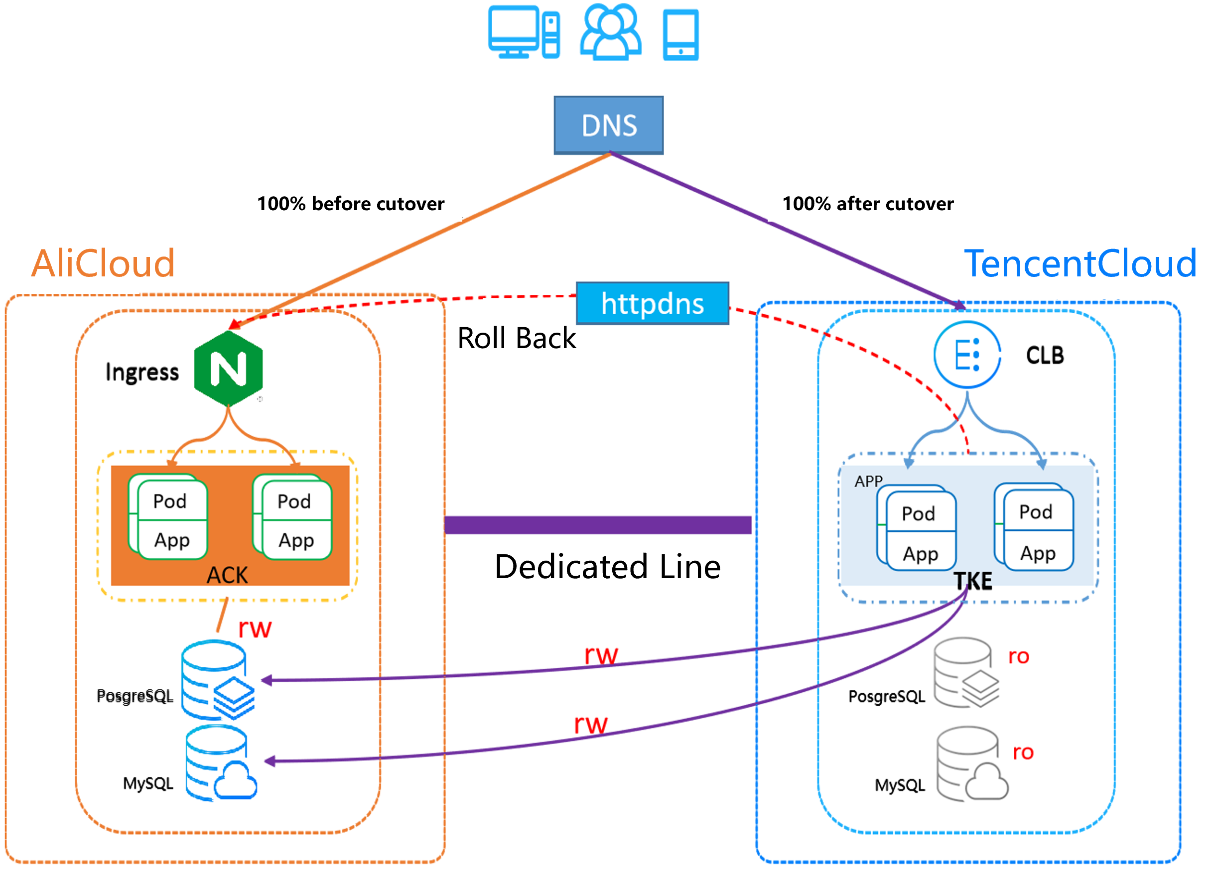
The key nodes of the full migration and cutover plan are described as follows:
- Determination of business downtime : business sensitivity , automation of cutover operations, and cutover drills to shorten downtime.
- IDC related business shutdown : If the business shutdown is not complete, it will lead to data inconsistency on both sides, and the risk of cutover and rollback is high. Therefore, after the business is stopped and written , it needs to be checked and verified to ensure that there is no read and write traffic in the business.
- Data consistency verification : During the business suspension period, the data on both sides of the business IDC and Tencent Cloud are verified for consistency. Currently, the DTS synchronization service supports assisting the business in verifying data consistency to ensure that the data on both sides is consistent.
- Business function testing and verification: During the business shutdown period, business functions and processes are fully tested and verified to ensure that the cloud environment can operate normally . After sufficient testing, it is recommended to delete the test data to prevent business data contamination.
- Business traffic switching : After the business is verified to be normal, modify the DNS resolution to Tencent Cloud and officially switch the traffic. Considering the TTL cache time of DNS, it is recommended to build a traffic forwarder in the IDC environment and forward the IDC public network traffic to Tencent Cloud 's CLB.
- Business monitoring alarms : During the cutover, in order to prevent alarm pollution, alarms in the IDC environment are suspended ; at the same time, in order to sense the business situation on the cloud , Tencent cloud side business monitoring alarms are added in a timely manner.
Smooth business cutover means that the new system will eventually replace the old system, but the migration period will be longer . During the migration, the business will run on the new and old platforms at the same time, and business traffic will gradually shift towards the new platform . Therefore, smooth migration has higher requirements for business decoupling and business traffic scheduling .
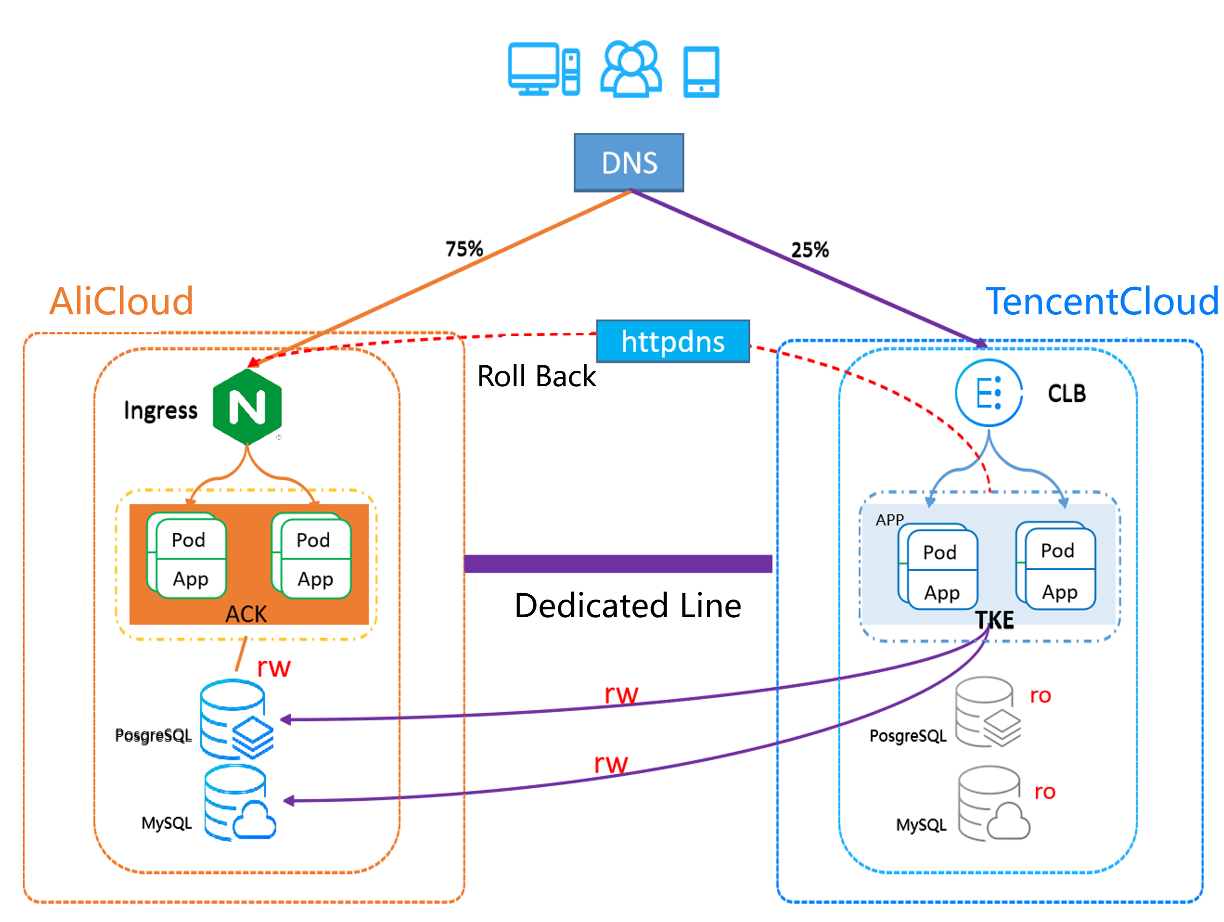
The key nodes of the smooth migration and cutover solution are described as follows:
- All business migration priorities : Follow the smooth migration of services from edge to core and from simple to complex.
- Business traffic cutover : DNS resolves 1% of traffic to Tencent Cloud for grayscale. At the same time, database reading and writing are still in IDC. After business grayscale is normal, business traffic will be gradually cut to Tencent Cloud .
- Database traffic cutover : If the business separates reading and writing, after the data is synchronized and consistent, reading will be cut first and then writing will be cut.
      - Rollback Plan Design
The business migration and cutover process , unexpected risks may arise . In order to deal with unexpected risks, the cutover business needs to be rolled back to restore the business and reduce the business impact.
A rollback plan are as follows:
- Rollback process decision-making : Enterprises need to formulate business rollback decision-making standards to reduce the time-consuming decision-making process for major events. Generally, the rollback solution is commonly used in full migration and cutover. For example, if the business problem is still not solved during the daytime peak period, a rollback is performed.
- Business stop and write test : Stop all Tencent Cloud services and check that there is no reading or writing in the database.
- Data consistency verification : During Tencent Cloud outage , Tencent Cloud data will be synchronized to IDC through Tencent Cloud data synchronization service to ensure data consistency.
- IDC business is fully tested : During the business suspension period, the business functions and processes are fully tested and verified to ensure that the environment can operate normally. At the same time, after sufficient testing, it is recommended to delete the test data to prevent business contamination.
- Business traffic switching : After the business is verified to be normal, modify the DNS resolution to the IDC and officially switch the traffic. Considering the TTL cache time of DNS, it is recommended to build your own traffic forwarder on Tencent Cloud and forward the traffic on the cloud to IDC.
    - Solution verification
Cloud migration tools and product functions are mainly used to meet general business scenarios. For special business scenarios and functional usage postures, the business needs to be tested to ensure that the overall solution is feasible. Special scenes are mainly divided into three categories:
- Business scenario restrictions: Restrictions on the use of cloud products. If cloud products do not meet business requirements , business scenario verification is required. For example, DTS requires the database MySQL version to be greater than 5.6 . For low-version source databases, the standard DTS solution cannot be used for data migration. The source database version needs to be upgraded or a customized solution needs to be tested and verified .
- Product customization support: mainly develop product customization functions for large cloud customers. For example, a large customer on the cloud requested double-write disaster recovery for the database . For this purpose, the cloud side customized and developed the DTS two-way synchronization function. This type of scenario needs to be drilled and verified.
- Application architecture transformation: Business applications are migrated to the cloud and are heterogeneous based on the current business framework. The business transformation plan needs to be verified.
    - Risk Management
The plan review team conducted a comprehensive review of the overall cloud plan , including technical review , risk management and control , code review, and human support. Finally, the cloud side , the customer side , and independent third parties reached an agreement on the overall cloud plan review conclusion.
  - Program implementation
After the overall cloud migration plan is formulated , the cloud migration project enters the plan implementation stage. The implementation of the plan is mainly divided into four steps, namely environment preparation , cloud migration rehearsal, cloud migration implementation and business cutover . Through the collaborative cooperation of multiple parties in project management and quality control, the enterprise's business will eventually be smoothly run on the cloud.
    - Environmental Preparation
Environment preparation is based on the cloud migration solution and involves resource creation and business deployment. The cloud platform provides Teleport tools to help enterprises create and deploy entire VPC resource applications on the cloud more efficiently and accurately.
    - Cloud Migration Drill
Cloud migration drills are conducted on the cloud platform based on business forms to ensure smooth business migration to the cloud. It mainly includes the following aspects:
- POC testing: Test and verify cloud platform tools, cloud products, and functional requirements combined with business.
- Performance testing: full-link stress testing of services to provide data support for subsequent business capacity management and resource expansion.
- Business testing: Conduct simulation testing of business functions and processes against the target environment.
- Migration drill: Based on the cloud migration plan and business scenarios, conduct a cloud migration simulation drill to confirm the network capacity, data migration time, business optimization and other iterative optimization of the cloud migration plan.
- Cutover drills: Mainly conduct drills for business system cutovers, continuously optimize cutover operating specifications and steps, control business impacts, and ensure the smooth completion of online cutovers.
    - Cloud Implementation
After the cloud migration drill is completed , the overall cloud migration plan is iteratively optimized and officially enters the cloud business deployment and implementation stage. At this stage, cloud solutions and plans need to be implemented, deployed, and focused on project management and quality control.
Project management is based on implementation planning and is executed as planned. If the project is at risk of delay, it will be escalated in a timely manner to ensure that cloud migration can be completed as planned.
Quality control mainly ensures that the cloud business production environment and the business environment to be migrated are consistent, including business functions, application versions, and data consistency.
    - Business Cutover
Business cutover requires the coordination and cooperation of all teams in the enterprise. In order to ensure smooth business cutover, it is recommended to learn from the following successful cutover experience.
- the cutover guarantee team : Operations, R&D, and testing teams work together to complete the business cutover.
- Standardize the cutover operation process : During the cutover, strictly abide by the cutover plan operation steps. Core operations and cooperation must be cross-checked and executed for secondary confirmation . If the business cutover process does not meet expectations, follow the established rollback strategy and decisively execute the rollback to reduce the impact on the business.
- Business trial operation guarantee : If an unexpected failure occurs during the business trial operation phase, emergency personnel should be able to deal with it in time. At the same time, the original production environment should be retained for a period of time (one week is recommended) to support business rollback .
  - Verification
During the business trial operation, the cloud migration process enters the acceptance and summary stage, which is mainly divided into cloud acceptance, cloud summary and cloud optimization. The focus of this stage is on cloud migration delivery and acceptance, summarizing experience in the cloud migration process , and combining cloud platform capabilities to guide subsequent business optimization.
    - New System Acceptance
The trial operation of enterprise applications on the cloud is normal, the cloud delivery acceptance will be carried out with the enterprise based on the acceptance criteria agreed upon by both parties in the early stage. Based on different customer situations, common acceptance standards refer to the following 4 dimensions:
- System availability: After the enterprise application system has just been put on the cloud, it is in the trial operation stage. The enterprise needs to conduct availability verification on the target environment, which mainly includes: system verification , business verification , traffic verification , performance verification and security verification .
- Business indicator verification: mainly includes business client indicators and back-end service availability indicators. Both can be used as acceptance criteria.
- High availability verification: If there is a disaster recovery part in the early design of the solution, it is necessary to conduct a drill for the expected disaster recovery scenario after the cloud migration is completed . The drill meeting the expectations is an important part of the acceptance criteria .
- Benefits of migrating to the cloud: Some businesses have high requirements for cost control, so after migrating to the cloud, an overall comparison of source and cloud cost consumption is required as one of the acceptance criteria .
    - Summary Of Cloud Migration
At the end of the project, it is necessary to conduct a comprehensive summary of the entire cloud migration project , accumulate experience for subsequent projects, and continue to improve cloud migration efficiency. This is mainly summarized from the following three dimensions :
- Three-dimensional project : sort out the entire project information, including cloud migration milestones, cloud migration plans, delivery outputs at each stage, etc.
- Commonization of solutions : Analyze and optimize problems encountered during the cloud migration process , improve product and tool capabilities, adapt the cloud migration solution to more business scenarios, and help make cloud business more stable.
- Process standardization : In the process of accumulating cloud migration experience , we will continue to optimize and iterate the cloud migration process to help enterprises migrate to the cloud more efficiently .
    - Cloud Optimization
TSA (Tencent Smart Advisor) helps customers optimize cloud infrastructure from the dimensions of security, reliability, and service limitations to improve system security and service reliability. It supports one-click inspection of cloud resources and provides online resource optimization suggestions based on actual business usage to efficiently improve business continuity.
TSA obtains resource information , usage methods, etc. through customer authorization and calls cloud API , discovers potential risks and gives optimization suggestions, mainly covering the following dimensions :
- Security : Improve application and data security .
- Reliable : Improve application stability .
- Cost : Alert and optimize inefficient use of resources .
- Performance : Experts screen high-risk indicators and optimize business performance .
- Service limitations : product limitations, usage postures, best practice pitfall avoidance guide .
